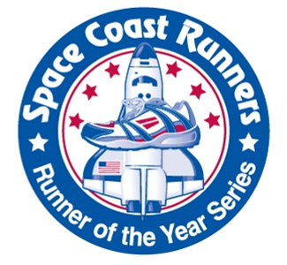

SCR Race Series Participation Agreement

As a participant in the Space Coast Runners 2016-2017 Runner of the Year Race

Series, I __________________________ , race director of the

________________________________________________________ (race name),

agree to the following:

- Include SCR logo on race brochures and T shirts, marketing your race as a Runner of the Year Event.

- All races should have identical age group categories, to include 5 year age groups (up to 75-79, 80+), and Master, Grandmaster, and Senior Grandmaster.

- All races will offer a minimum $3 discount to SCR members.

- SCR offering $20 entries to anyone signing up for the entire SCR Race Series.

- In return for 1(one) free entry voucher (for raffle purposes) to the Space Coast Marathon or Half Marathon, you will allow SCR to give 6 free entries to your race for use in SCM Volunteer Appreciation Packets.

- Provide Space Coast Runners with timely, pertinent race information for SCR promotion. (See Page 2) All SCR ROY races will get one free ad in the SCR Newsletter, along with 2 eBlasts sent out approximately one month and again 2 weeks prior to their race. In addition, we will use social media to further promote all races to our membership and beyond.

- For the SCR Youth Series, the following shall appear on your race entry form:
‘SPACE COAST RUNNERS YOUTH SERIES RUN – (expected run time) open to age 12 and under, ¼ mile, ½ mile, or 1 mile runs. Parents must sign a waiver onsite, participation awards to all!’

Signed __________________________________________Date________________

The SCR newsletter will highlight your race in an issue prior to the event’s date. Please provide us with the following information.

Race name__________________________________________________________________

RD name/email_______________________________________________________________

Website _____________________________________________________________________

Date________________________________ Start Time______________________________

Early Registration fees for SCR members. Adults ___________ Students_________

Late registration cost _______________and date it takes effect___________________

Type race shirt? Tech or cotton No shirt option? Yes no

Are you guaranteeing shirts for certain # of participants? If so, what’s your #______

Will you be offering a finisher medal yes no

Will you be offering any sort of special swag?

What is your Youth Series plan and start time?

Tell us about the planned post-race awards and ceremony.

Is this an anniversary year or a special year for the race?

Do you have any course records or information you would like us to mention?

Will there be entertainment at your event?

Are you using a special event hashtag that we should mention in promotions?

